Thulium fiber laser performance: theory and experimentation

Alexander M. Friedrichsen

Senior Thesis prepared for the Degree of

Bachelor of Science

UNIVERSITY OF NORTH TEXAS

MAY 2021

APPROVED:

David Shiner, Senior Thesis Advisor

Table of Contents

Abstract 3

Introduction to The Laser Fiber Setup 3

Thulium Levels and Their Methods of Deexcitation 4

Explanation of Phonon Decay and Its Side Effects 6

High-Density $s2$ State Cooperative Decay 7

Fiber Bragg Grating Design and Function 9

Introduction to The Required Equations and Constants 10

Procedure: 11

Utilizing Equation 3, The Equilibrium Equation 13

Adjusting the Right-Hand Side and Middle of The Equilibrium Equation 14

Implementing Time Dependence 14

Implementing the Observable $P0 and Pt$ 17

# Abstract

A specific discrepancy between theory and experiment was found regarding a Thulium-doped fiber laser that was constructed for atomic spectroscopy. When implementing Thulium doping within a fiber laser, a certain threshold power must be met before any output fluorescence can be detected. This experiment detected a Threshold Power of 1.7 Watts, almost twice the theorized threshold power. Analysis within this article describes the equations and derivations responsible for the overall model of the laser. Cross referencing previously found data and interpreting simulated experiments using Wolfram Mathematica assisted in the determination of a cause for the discrepancy within the initial experiment of the Thulium fiber laser.

# Introduction to The Laser Fiber Setup

The following experiment tests the performance of a 2.15 m Thulium-doped fiber laser (Figure 1) with an 8-Watt BWT Beijing LD at 790 nm as the pump source. The maximum power used for this experiment is roughly 3 Watts. The Thulium atoms infused within the fiber have a population density quoted by the fiber manufacturer of $3×{10}^{26}\frac{Tm atoms}{m^{3}}$. These atoms are excited along the fiber by the LD source, but quickly deexcite and emit their own photons at $λ=2058 nm$. Ideally, these $2058 nm$ photons will exit the cavity as the laser output. The laser fiber contains a high-reflecting FBG mirror at the end of the laser cavity where only a small band of wavelengths $±1.2 nm$ within the $2058 nm$ target is reflected back along the fiber to lase at a maximum power of 3 Watts and a slope efficiency of around 50%. The vertical pairs of grey lines in Figure 1 represent the two locations where the fiber was spliced and fused back together for a near 1% loss for each splice. This multiplies the transmission of the signal by a coefficient of ${.99}^{4}$ since the signal will pass through both splices and also be reflected back through both splices after hitting the FBG. Figure 1 (below) depicts an orange rectangle that represents an ITF Technologies (2+1)x1 Side Pump Combiner. The combiner in that figure shows a second wire feeding into it, as it is capable of combining two separate inputs into 1 output. However, only a single input it utilized in this experiment.

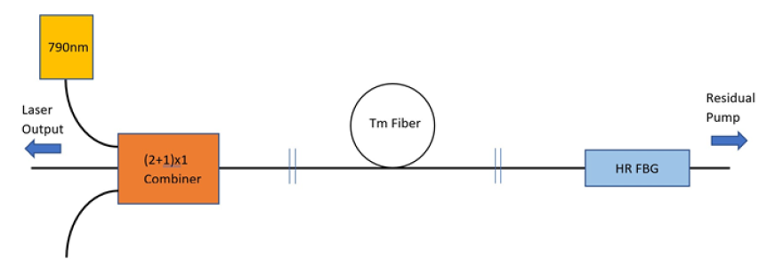

Figure 1. The Thulium Laser System and Components (* Quote Ronnie’s Thesis for this image *)

The fiber connecting the 790 nm source and the pump combiner is different from the rest of the fiber. This beginning fiber is a $105 μm$/ $125μm$ fiber with a numerical aperture of .15. It was made to fit into the side pump input, however, the $10 μm$/ $125μm$ fiber that comes after the combiner was not. The original literature mentions implementing cutback experiments until a loss of only 5% was met when transmitting the light from the combiner into the double clad, Tm-doped fiber. Further below, this will be referred to as $T_{c}.$ As the light from the 790 nm source pump is absorbed by Tm along the length of the fiber, more 2058 nm light is sent through the rest of the fiber to be observed at the cleaved end of the cavity in Figure 1. In theory, the output laser light from the fiber at 2058 nm would be used for atomic helium spectroscopy to eliminate certain states from a helium population inside a separate vacuum system. Before this can happen though, it’s necessary to make sure the theoretical and experimental threshold power for this fiber laser agree with one another. Further into the article, it is concluded that determining the decay rate of excess fluorescence exiting the fiber is the most experimentally reliable way to determine a corrected version of one of the constants that this experiment heavily depends on.

# Thulium Levels and Their Methods of Deexcitation

Using a 790 nm laser diode will produce photons equal to 2.5 eV, enough to excite the Thulium atoms briefly into an unstable excited $s_{3}$ state. This state lasts a brief and frankly, negligible amount of time (on the scale of nanoseconds) before it relaxes down to the metastable $s_{2}$ state. This state’s natural lifetime $≈$ 480 $μs$ in the absence of a high population density. Based on Equation 3, quoted from the original experiment’s literature, the lifetime of the Thulium’s $s_{2}$ state is heavily dependent on the population density of $s_{2}$ state atoms. The $s_{2}$ state does not immediately go back down to the ground state.

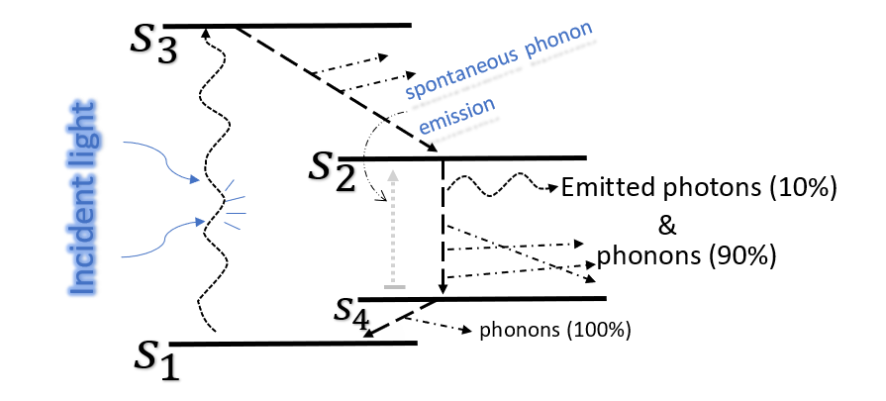

Figure 2. Shows the level diagram for Tm atoms as they excite within the laser.

There is another state that will be referred to as an unstable and very low energy $s_{4}$ state. It’s important to note that the photon emission that can occur during the decay from $s_{2}$ to $s_{4}$ is of wavelength $λ=2058 nm$. This is the expected wavelength of the output fluorescence of the laser. Despite the large amount of excited state Tm atoms, only about 10% of those atoms decay through radiative stimulated emission. The other 90% spontaneously decay through phonon emission, a vibrational energy expelled throughout the lattice structure of the atom itself.

If a higher percentage of those atoms exhibited photonic decay in the transition from $s_{2}$ to $s_{4}$ then it would likely result in a lower required power required to produce an output fluorescence power by the laser ($P_{thresh}$). This would also cause a drastic decrease in the lifetime of atoms in the excited $s_{2}$ state. Excitation to the $s_{2}$ state means more light exiting at the desired wavelength of 2058 nm, but also means that those $s_{2}$ states last a much shorter time. Essentially, harder pumping of the fiber results in a higher rate of Tm entering the $s_{2}$ state. Conversely this also means those states will decay more rapidly, and thus a consistent pumping of the fiber is required to maintain a high number of 2058 nm photons exiting the fiber per second. One challenge in the experiment is the fact that the round-trip gain within the system must be equal to the loss throughout the fiber. The loss is considered as any light that leaves the laser cavity rather than being reflected back into it. Losing light through efforts such as coupling light from the combiner into the Thulium doped fiber also count towards this loss. When initially tested, the end of the laser cavity only had Fresnel Reflection occurring with the air-glass interface for a 3.3% reflection of light back into the fiber.

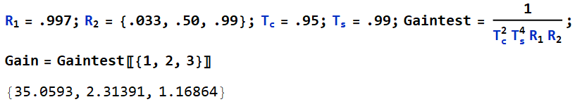

Figure 3. Separate reflectivity values tested for $R_{2}$ to create different results for loss and gain.

Instead of this 3.3%, other, higher reflectivity values were tested in Mathematica. The 3.3% reflectivity resulted in a loss of 96.7% of the light, so a very large gain of 35.06 seen in Figure 3 was required to compensate for it. This gain is required of each round trip from photons that get reflected back into the fiber. Using the larger values for reflectivity ( $R_{2})$ made this gain value much smaller with values of 2.31 and 1.17. $R_{1}$ represents the reflectivity of the FBG used at the right end of the fiber cavity seen in Figure 1. $T_{s}$ represents the transmission coefficient of light going through the fiber splices. As mentioned earlier in the article, 5% was lost through $T_{c}$, the coupling of light from the combiner into the active Tm fiber.

## Explanation of Phonon Decay and Its Side Effects

There is a step in the process of decay from 🡪 that explains where the phonon-emitted energy goes. While it wasn’t mentioned initially, this step in the process is vital to the efficiency of the overall laser. On top of this, the 🡪 transition is the only decay transition that actually emits photons. The remaining decay transitions are performed through spontaneous phonon emission. The nature of phonon emission can be affected by the density of the population of atoms. When phonon energy is released, nearby atoms may be influenced by it and potentially absorb the nearby lattice vibrations. To reiterate, a Thulium atom quickly decays from the $s_{3}$ to the $s_{2}$ state where its energy upon demotion is given to a neighboring ground state Thulium atom via phonon interaction. In turn, this promotes the neighboring atom to the $s_{2}$ state as the original Tm atom decays down from the $s_{3}$ to the $s_{2}$ state. This results in a 2 for 1 phenomenon where one photon of 790 nm light ended up creating two $s_{2}$ state Thulium atoms. Once this step is complete, both Tm atoms will relax back to the ground state after about $τ$ =480 $μs$ or less depending on the concentration of excited state Tm at the time. When Tm relaxes down from the $s_{2}$ state to the 🡪 ground state, either photons or phonons will be emitted. 90% of the deexcitation from this will consist of the spontaneous emission of phonons, but the emitted photons will have wavelengths of 𝜆 = 2058 nm and energy of $≈.6 eV$ that are sent through the fiber. Photons are more likely to be emitted as stimulated emission, whereas phonons are almost always emitted spontaneously. The 🡪 ground state transition is incredibly quick and consists of only phonon emission through its decay process. This happens because at such small changes in energy it’s more convenient for the atom to vibrate within its own lattice rather than to emit a photon of incredibly low energy. There is a slight quantum defect because the difference in energy between the $s_{3}$ and $s_{2}$ state isn’t exactly the same as the difference in energy between the $s_{2}$ and $s_{4}$ state. However, this deficiency has been determined to be inconsequential to the overall lasing process.

# High-Density $s_{2}$ State Cooperative Decay

Often times in the cooperative decay, there will be two components of the decay rate. These are the phonon decay ($γ_{phon}$) and photon decay ( $γ_{phot})$ that add up to be the natural decay rate $γ_{0}$.

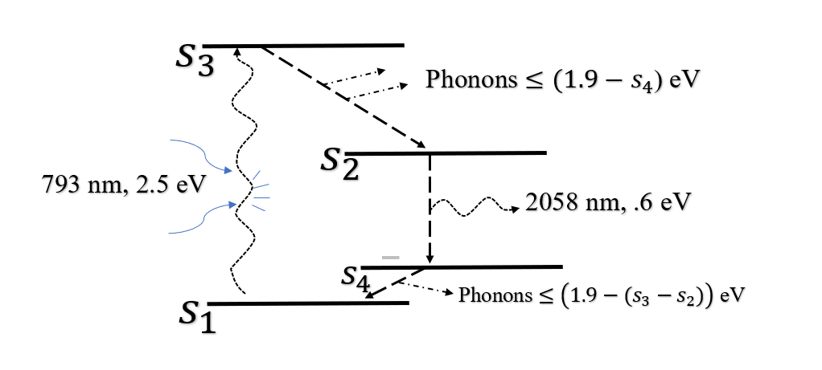

Figure 4. Illustration of energy differences for Thulium energy levels.

Despite having two different methods of decay, only one of those methods helps in creating a laser output. It would be optimistic to think that even though only 10% of the 🡪 transition results in 2058 nm photons, each phonon exerted will produce a new, nearby $s_{2}$ state atom. This is because even though the phonon decay from 🡪 *can* excite a nearby atom, doesn’t mean it always does. Initial testing for this experiment in the original literature came with a 1.6 Cross Relaxation Efficiency (CR) but was not independently measured as quoted by the original literature. Had it been 100% of the time, a 2:1 phenomenon would truly have occurred with a CR of 2.0. Some other experiments have yielded an impressive CR of 1.8. This lack of consistency could stem from an insufficient population density of Tm atoms, or other small factors.

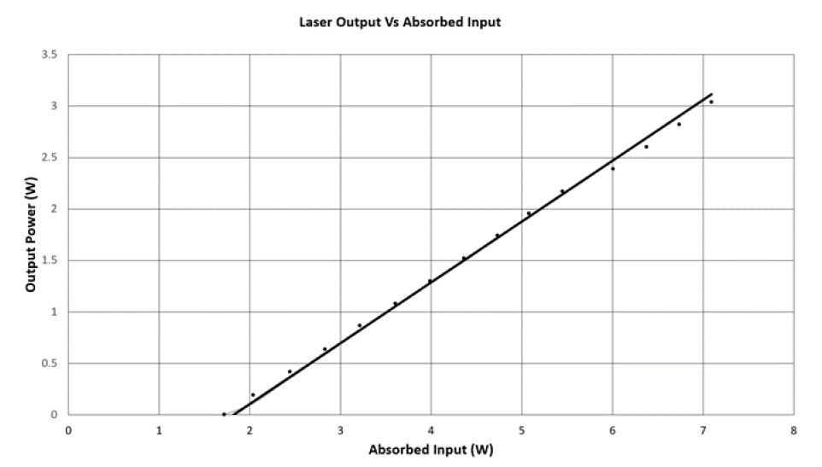

Figure 5. Slope Efficiency and Threshold Power graph.

Figure 5 can be used to find a slope efficiency of 60% with respect to the Absorbed Input. The Threshold Power is also seen to equal the 1.7 Watts as stated within the original literature. This is the point where the original theory had realized an expected Threshold Power of around half of what is seen in Figure 5. Resolution to this discrepancy is explored in the upcoming sections of the document.

# Fiber Bragg Grating Design and Function

This experiment utilizes a 1.1 mm long highly reflective ($R_{1}=99.7\%$) Fiber Bragg Grating (FBG) for the purpose of reflecting as many 2058 nm photons as possible. The FBG contains a series of closely spaced gratings called fiber gratings that filter incoming light. Each grating filters out a small band of wavelengths, leaving only a narrow range ($±1.2 nm$) of wavelengths left to be reflected. The grating spacing ($\text{Λ}$) for the proposed wavelength of 2058 nm needs to equal $\frac{λ}{2n}$ where n is the refractive index of the fused silica inside the fiber. When substituting in the known values of the desired wavelength and the refractive index of the fused silica, this is the result.

$$\text{Λ}=\frac{2058×{10}^{-9}}{2×1.45}=.71 μm$$

A photon with a specific wavelength will only reflect off of something if the space between the 2 surfaces it reflects off of is equal to itself over 2 times n. Otherwise it will pass through or be absorbed. This is why the grating spacings are all augmented to be near 710 nm. There are two different ways in which the distance of the grating spacings are augmented. The first and main contributor to grating spacing change is a change in the refractive index. The refractive index of the fused silica is equal to about 1.45 at room temperature. The second contributor is thermal expansion, but this is only about a fifth as effective as the refractive index change. The target temperature range is between 22 and 27 $℃$ for varying input currents. Within this range the rate of change in grating spacings is $0.21 nm/℃$. or $1.2 GHz/℃$ if both contributors are considered. It wasn’t intended for the wavelength selection to be extremely dependent on temperature, and so only about a change of 1 $℃$ is every really made. These measurements were made within the original literature and only the math behind them needed to be confirmed.

The two k values and $N_{2}$ values were found using different methods. The literature k value was taken from the original literature and equated with our rate-in expression in order to keep the variables from each expression related. The supposed corrected value for k is about 5 times larger than the literature value and was found by making k a dependent of $N_{2}$. $N_{2}$ was determined through the utilization of the Gain equation, which is independent of the Rate Equation. After finding an independent $N_{2}$ value from the Gain Equation, this is plugged into the rate equation in Wolfram Mathematica and solved for a new value of k. This k was also found using the experimental values of fiber length 2.15 m, and absorption power 1.7 W.

# Introduction to The Required Equations and Constants

With there being multiple steps throughout the experiment, multiple equations are required to comprise of the official model of the experiment. There will be 4 main equations that are utilized in this experiment, beginning with Equation 1. Equation 1 describes the gain of the system by using the already known variables of emission and absorption cross section. $n_{2}$ and $n_{1}$ are found through utilizing equation 2 and its sub-equation. Later in Equation 3 and its revised form, the cross relaxation, energy per photon, and threshold are used to determine an effective lifetime for the excited state Thulium atoms.



$G=e^{Γ}\int{(n_{2}\left(x\right)σ_{e}-n_{1}\left(x\right)σ_{a}dx}$

$G{=e}^{\frac{2Γ}{A}}(N_{2}σ_{e}-N_{1}σ_{a})$

$N_{total}=\int{n_{thul}}dV$

$N_{total}=N_{2}+N_{1}$

$\frac{\left(CR\right)P_{th}}{{hv}_{pump}}=\int{(γ_{0}+2kn_{2})n_{2}dV}$

${\frac{\left(CR\right)P_{th}}{{hv}_{pump}}=γ}_{0}N_{2}+\frac{2kN_{2}^{2}}{V}=\frac{N_{2}}{τ_{eff}}$

Each of these equations will be revised and manipulated to be made capable of providing the best fitting theoretical model to accurately replicate results that would normally be found through physical experimentation. Important constants are mentioned in table 1, below.

|  |  |  |
| --- | --- | --- |
| Variable | Meaning | Value |
| $${hv}_{pump}$$ | Pump Photon Energy | $$=2.5 eV$$ |
| $$P_{th}$$ | Threshold Power | $$=1.7 W$$ |
| CR | Cross Relaxation Coefficient | $$=1.6$$ |
| $$N_{2}$$ | Population in Excited State | $$= ?$$ |
| $$n_{thul}$$ | Thulium Concentration in Fiber | $$=3×{10}^{26}m^{3}$$ |
| $$N_{total}$$ | Total Number of Thulium Atoms | $$=n_{thul}×Volume$$ |
| $$γ_{0}$$ | Natural Decay Rate | $$=480 s^{-1}$$ |
| k | Literature k Constant | $$=1.5×{10}^{-23}$$ |
| $$α$$ | Absorption Coefficient | $$=1.059$$ |
| $$n_{0}$$ | Initial Excited State Density @ $l=0$ | $=$ |
| $$n_{2}$$ | Excited State Density at $l≠0$ | $$=n_{0}\left(e^{- α l}\right)$$ |
| G | Round Trip Gain | $$= 35.06$$ |
| $$σ_{e}$$ | Emission Cross Section | $$=9×{10}^{-26}m^{2}$$ |
| $$σ_{a}$$ | Absorption Cross Section | $$=2.8×{10}^{-28}m^{2}$$ |
| $$Γ$$ | Modal Overlap | $$=0.75$$ |
| $$\text{Λ}$$ | Grating Spacing | $=$ 1.1 mm |
| $$τ_{eff}$$ | Effective Lifetime | $$= ?$$ |

Table 1. A list comprised of the constants used within the 4 main equations.

# Procedure:

The first step is to turn on the pump laser and steadily increase the input power until it reaches the threshold power in order to begin lasing. With a 2.15 m fiber wire, the input power is increased up to 3 Watts. Once a steady state is met, the laser should excite around 4.087% of the Thulium throughout the length of the 2.15 m fiber. This is found by using Equation 1 and Equation 2. The following process was used in Mathematica to find the value of $N_{2}$.

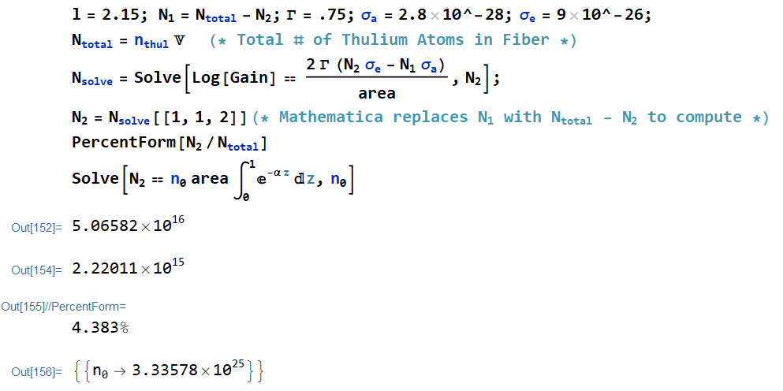

Figure 6. A screenshot of Mathematica code showing the overall population of $s_{2}$ state Thulium within the whole 2.15 m fiber.

Once the percentage of $s_{2}$ state Tm atoms is calculated, the laser can be turned off. What happens after the laser turns off is paramount to the analysis of this laser system and finding out why the original literature had its discrepancy. While 4.83% of excited state Tm sounds rather low, it could have been much lower. Had $R_{2}$ been higher such as 50% or 99%, the $s_{2}$ population would have looked more like the following.

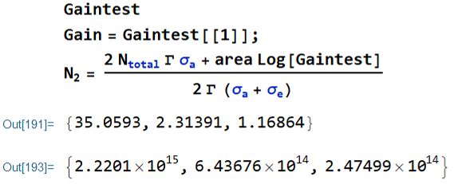

Figure 7. Showing the different $N_{2}$ values that correspond to changes in Gain.

$N_{2}$ from Figure 7 denotes the total population of $s_{2}$ state Tm atoms and will be used regularly from here on out. With a 99% reflector coupled at the fiber cavity’s end, there would have been merely a tenth of what was seen of $N_{2}$ with the 3.3% Fresnel reflection. From here, the question is about how much the population density ($n_{2}$) changes along the length of the fiber due to attenuation.

Figure 8 represents the decrease in the population density ($n_{2}$) along the length of the fiber.

Figure 8 shows what is originally a linear-looking slope that falls off to become an exponential decay slope. It’s difficult to model the experiment with a continuously changing $N_{2}$ value, so it’s best to try using only a short piece of the fiber while keeping the rest of the variables the same. Once this is done in Figure 9, it’s easy to see that within the first 10 cm of fiber, $n_{2}$ only changes by roughly 10 percent. It would be ideal to have this even lower, but at least with a linear slope, the average can be taken and used for a reliably accurate model.

Figure 9. Depicts what the practically linear slope of $n_{2}$ looks like within the first 10 cm.

# Utilizing Equation 3, The Equilibrium Equation

$${\frac{\left(CR\right)P_{th}}{{hv}_{pump}}=γ}_{0}N_{2}+\frac{2kN_{2}^{2}}{V}=\frac{N_{2}}{τ_{eff}}$$

What will be done with this equation is first, equating the left and middle part to provide an understanding of what the values should be with the new, 10 cm length of fiber: specifically, $N_{2}$. This way, $N_{2}$ will remain more or less constant throughout the whole length of the fiber.

$${\frac{\left(CR\right)P_{th}}{{hv}_{pump}}=γ}_{0}N_{2}+\frac{2kN_{2}^{2}}{V}→\frac{\left(1.6\right)\left(1.7\right)}{2.515eV}=\frac{1}{\frac{480}{{10}^{6}}}×N_{2}+\frac{2\left(1.5×{10}^{-23}\right)N_{2}^{2}}{.1×Pi×5×{10}^{-6}}→$$

$$1.05×{10}^{18}=\left(\frac{6250}{3}N_{2}+1.91×{10}^{-17}N_{2}\right)→N_{2}=3.185×{10}^{14}=13.52\%$$

There are many variables within this equation, and a few of them are independently measurable which makes them concrete. k is not one of those variables. In the original literature, it was stated that k was taken from an outside source, but after some reading over those sources it was determined that k might not be entirely meant for this sort of experiment. A different k value may yield more accurate results for this experiment. The goal is now to find a correct k and also a way to compare it to experimental results. With Mathematica, a new k value of 5 times the original at $7.844×{10}^{-23}$ was found. Using the new k value in the above equation would yield an $N_{2}=1.90×{10}^{14}=8.07\%$ of the total number of Tm atoms in the 10 cm of fiber.

## Adjusting the Right-Hand Side and Middle of The Equilibrium Equation

Before moving onto the next section, it would be wise to make a more convenient notation of equation 3 but focusing on the right and middle portions of the equation.

$$γ_{0}N_{2}+\frac{2kN_{2}^{2}}{V}=\frac{N_{2}}{τ_{eff}}→N_{2}\left(γ_{0}+\frac{2kN_{2}}{V}\right)=N_{2}γ_{eff}→γ_{0}+\frac{2kN_{2}}{V}=γ_{eff}→γ_{0}\left(1+\frac{2kN_{2}}{γ_{0}V}\right)=γ_{eff}$$

Here, a concrete definition for the effective decay rate is found, and for convenience’s sake, $\frac{2kN_{2}}{γ_{0}V}$ will be called $r_{γ}$. Calling it $r_{γ}$ will prove helpful within the upcoming differential equations of this equation. If $τ_{eff}$ is mentioned, it will just be the inverse of $γ_{eff}=γ_{0}\left(1+r_{γ}\right)$.

# Implementing Time Dependence

In order to bring time into the equation, the Equilibrium equation will need to be manipulated with a few of the following steps. First, consider the equation to be a much simpler version of itself such as $N_{2}γ_{0}+N_{2}^{2}=N_{2}\left(γ_{0}+N_{2}\right)$ where $dN_{2}=-N_{2}\left(γ_{0}\right)dt→$

$\int_{N_{0}}^{N_{2}(t)}{-\frac{dN_{2}}{N_{2}γ_{0}}=\int_{0}^{t}{dt}}→-\frac{1}{γ_{0}}(ln{N_{2}}-\ln{N_{0})=t→ }\ln{\frac{N_{2}}{N_{0}}=}-γ_{0}t→\frac{N_{2}}{N_{0}}=e^{-γ_{0}t}$ and this should end up giving a value of $N_{2}=N_{0}e^{-γ_{0}t}$. This may have been an overly simplified version, but through some clever coding in Mathematica, the more complicated equation was found to produce Figure 10, below. The proof consisted of a formula that added more variables to it as the completeness of the equation progressed. Filling in those blanks manually in here would look like $-\frac{e^{Vγ_{0}c_{1}}Vγ_{0}}{{\left(e^{tγ_{0}}-2e^{\left(Vγ_{0}\right)}k\right)}^{2}}\left(\left(e^{tγ_{0}}-2e^{\left(Vγ_{0}\right)}k\right)γ_{0}+\frac{2k}{V}e^{\left(Vγ_{0}c_{1}\right)}Vγ_{0}\right)$ and simplifies to equal

$-\frac{ⅇ^{tγ_{0}+Vγ_{0}c_{1}}Vγ^{2}}{{(ⅇ^{tγ}-2ⅇ^{Vγ_{0}c_{1}}k)}^{2}}$. To get rid of the integration constant $c_{1}$, a dummy variable of A was used in

terms of $N_{0}$ to create the finished differential equation in terms of $N_{0}$. This appears as $\frac{N0Vγ}{2(-1+ⅇ^{tγ})kN0+ⅇ^{tγ}Vγ}$ in Mathematica but will soon be reworked to look cleaner.

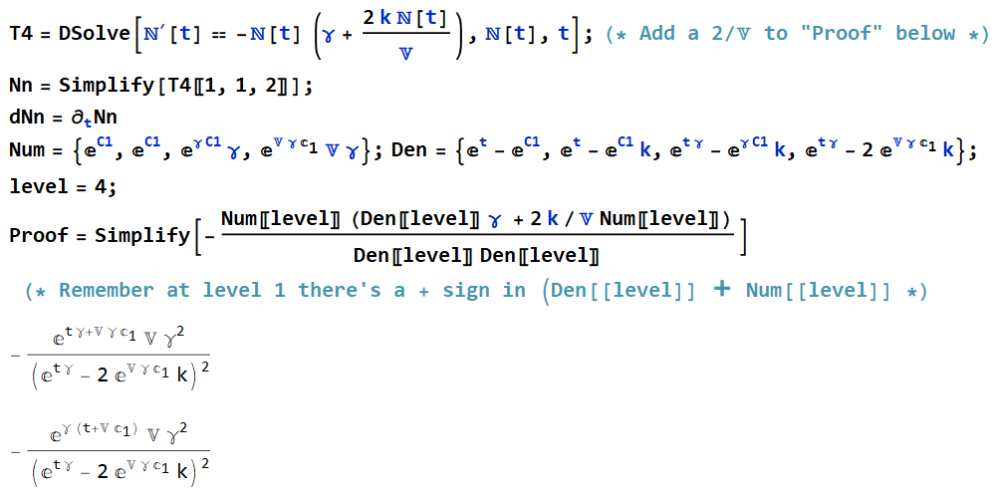

Figure 10. Mathematica code that utilizes Differential function and a semi-manually written way to confirm the same result.

First, it’s necessary to check and see if making $t=0$ for $\frac{N0Vγ}{2(-1+ⅇ^{tγ})kN0+ⅇ^{tγ}Vγ}$ results in a simple value of $N_{0}.$ With $t=0$, the term inside the bottom denominator disappears and $ⅇ^{tγ}Vγ$ turns into just $Vγ$ that will inevitable be cancelled by the $Vγ$ in the numerator, resulting in just $N_{0}$.

$$\frac{N_{0}Vγ_{0}}{-2kN_{0}+2kN_{0}e^{tγ_{0}}+ⅇ^{tγ}Vγ}=\frac{N_{0}Vγ_{0}}{Vγ_{0}\left(-\frac{2kN_{0}}{Vγ_{0}}+e^{tγ_{0}}\left(\frac{2kN_{0}}{Vγ_{0}}+1\right)\right)}=\frac{N_{0}}{-\frac{2kN_{0}}{Vγ_{0}}+e^{tγ_{0}}\left(\frac{2kN_{0}}{Vγ_{0}}+1\right)}$$

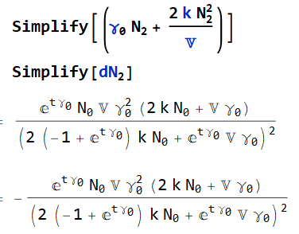This iteration of the equation contains exactly what was previously defined as $r_{γ}=\frac{2kN_{0}}{Vγ_{0}}$, and so that will be subbed in for the other variables to clean up the equation even more to end up with –

Figure 11. A Mathematica-derived equality between the change in $N_{2}$ over time and the middle section of the Equilibrium Equation.

$\frac{N_{0}}{e^{tγ_{0}}\left(r_{γ}+1\right)-r_{γ}}=N_{2}$ and now there is a unique formula for $N_{2}$ at any time, t after the pump is turned off, and only excess $N_{2}$ atoms are left to decay and fluoresce. What’s required is to compare the decaying $N_{2}$ to the similar, but not identical decay slope of the Power Output in terms of fluorescence. Taking the derivative with respect to time will provide the rate at which $N_{2}$ decays at any given point in time. This is equivalent to the rate out of $N_{2}$ from Equilibrium Equation. There is a negative in front of ${dN}_{2}$ and not the original equation because ${dN}_{2}$ considers the negative slope. Two helpful graphs are provided below that utilize ${dN}_{2}$ and also use the definition of the Effective Lifetime to show its own growth as $N_{2}$ decays. The original literature value of k is used in comparison to the potential corrected value of k.

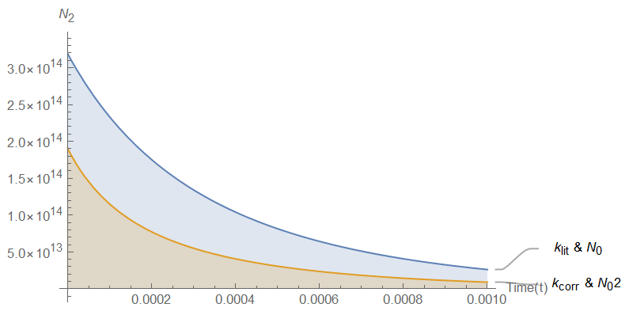

Figure 12. A depiction of the decay of $N_{2}$ in relation to time and dependent on 2 separate k values – one from the original literature, and another as the potential corrected k value.

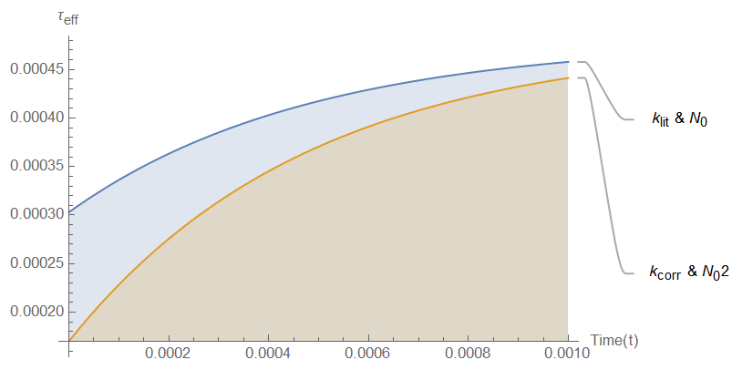

Figure 13. A depiction of the corresponding Effective Lifetime ( $τ_{eff})$ with respect to time while utilizing two separate values of both $N_{2}$ and k.

# Implementing the Observable $P_{0} and P_{t}$

While producing a differential equation over the middle section of Equation 3 was a good achievement, just a little bit more is required in order to determine a suitable value of k. Knowing the $N_{2}$ and its rate of decay once the pump is turned off would be helpful if it were possible to witness and keep track of each and every $N_{2}$ decay inside the laser fiber. Unfortunately, that feat isn’t possible, and so it’s necessary to resort to something that is measurable by observation. This key to resolution would happen to be the Power of fluorescence coming out of the fiber at times $t≥0$. The output power of the laser should be correlated to the rate out of the $s_{2}$ state within the fiber, but not identical. This means there should be a coefficient in front of the power output in order for it to ever be equal to $N_{2}(t)$. If the initial power out is known to be

$P_{out}=P_{in}e^{-αl}=1.7$, then the constant in front would just have to be this initial $P_{out}$ divided by the initial rate out. The initial rate out was found earlier to equal the rate in of $1.05×{10}^{18}$. This leave $P_{out}$ at time(t) to be $P\left(t\right)=\frac{P_{0}\left(γ_{0}N_{2}+\frac{2kN_{2}^{2}}{V}\right)}{γ_{0}N_{0}+\frac{2kN_{0}^{2}}{V}}$. Using this with different k and $N_{2}$ values in Mathematica resulted in Figure 14, below.

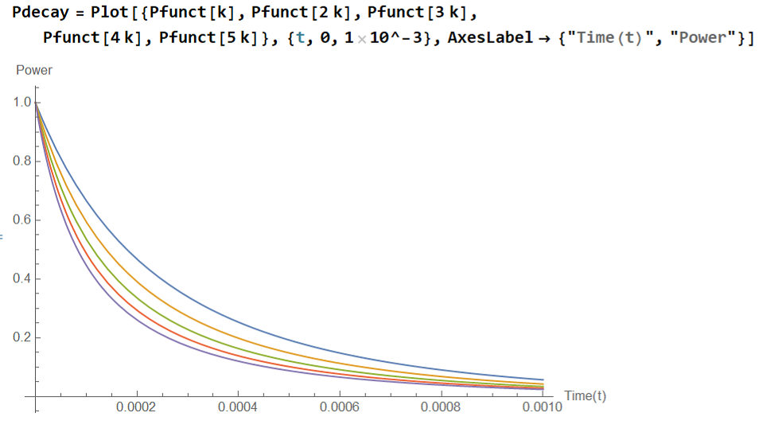

Figure 14. This plot function shows a decay of the $P_{out}\left(t\right)$ over the course of a millisecond. This hints towards an exceedingly fast d $P_{out}\left(t\right)$ with respect to time.

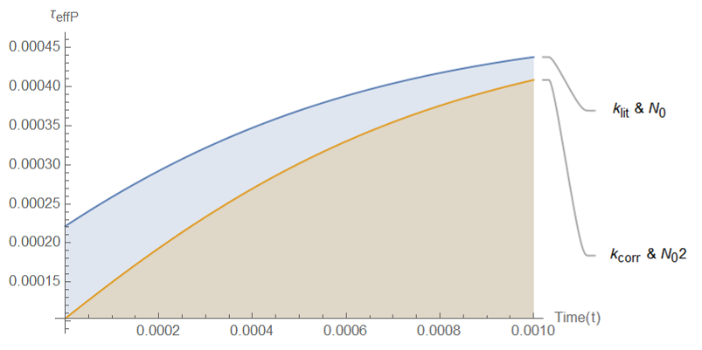

Figure . This shows the $P_{out}$ counterpart to the change in Effective Lifetime $τ_{eff}$.

The two plots for Effective Lifetime (Figure 13 & 15) will look similar to one another, just as the formulae did, however, the $τ_{eff}$ for $P_{out}$ actually starts off at an even shorter Lifetime. Figure 16 will show exactly how fast change in $P_{out}$ is over time. The graph in Figure 14 was made to be normalized by dividing the function by the initial $P_{out}$ so it would start at 1.0 and peter out from there with an apparent exponential decay.

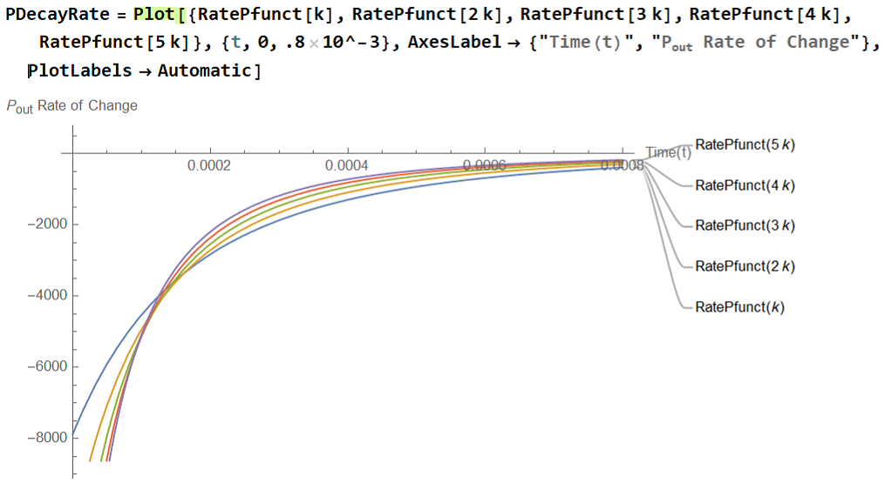

Figure 16. Another $P_{out}$ graph but this time exemplifying its alarming initial rate of decay.

Now knowing the similarities between $P_{out}$ and $N_{2}$, combined with the ability to normalize each will provide enough theoretical data to compare to actual experimental results. Specifically, Figure 14 will be able to verify which value of k is actually the k that fits the experiment at hand. Essentially, all that’s needed is to run a new experiment and plot enough theoretical k values that affect the $P_{out}$ trajectory, that when comparing the theoretical and experimental data, there is bound to be one k value that makes the two graphs match. This will be the final corrected value of k, thus allowing for the lasers next task of performing atomic Helium spectroscopy.